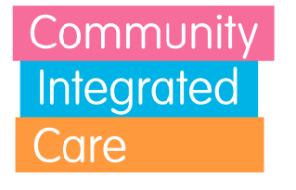

As an equal opportunity’s employer, Community Integrated Care actively strives to achieve the fair and equal treatment of all colleagues, regardless of gender. We will continue to follow our passion, to lobby the Government to increase funding to the care sector, to enable us to pay colleagues the rate of pay they deserve.
Community Integrated Care is pleased to publish details of its Gender Pay Gap in accordance with the Government’s Gender Pay Gap legislation.
The information collected as of 5th April 2021 for the previous 12 months shows:
Gender Pay Gap Overview
Mean Gender Pay Gap | 5.4%
Median Gender Pay Gap | 2.1%
Mean Bonus Pay Gap | 0%
Median Bonus Pay Gap | 0%

Gender Breakdown
 | Male | Female
Number of Colleagues | 908 | 3236
Mean Hourly Rate | 10.55 | 9.98
Median Hourly Rate | 9.03 | 8.84

Pay Quartile | Female Proportion | Male Proportion
Upper Quartile | 80.5% | 19.5%
Upper Middle Quartile | 80.8% | 19.2%
Lower Middle Quartile | 79.2% | 20.8%
Lower Quartile | 75.4% | 24.6%

Our mean gender pay gap is 5.4% and median pay gap is 2.1%. Whilst this is very low compared to the national average of 15.4 %, we will continue to strive to reduce this gap by building on the foundations of our fair and transparent pay framework. We have made further progress this year through the introduction of an organisational design framework throughout the Charity.
We continue to demonstrate fair pay and equal opportunity to progress throughout the organisation for all of our colleagues regardless of all individual characteristics.

